**8 Topics from Chapter 1**

*Knowledge Society*

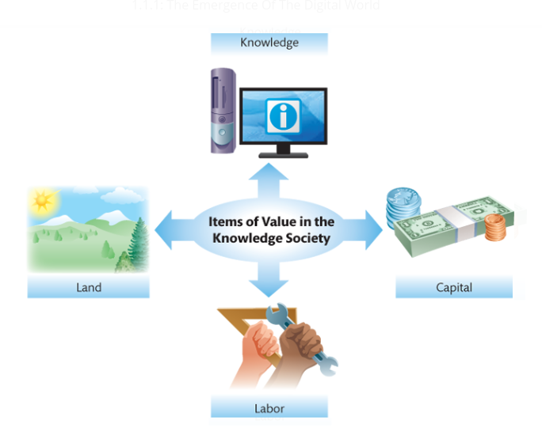

In 1959, a man named Peter Drucker predicted that information and information systems would become increasingly important, and at that point, he coined the term [knowledge](https://etext.pearson.com/eps/pearson-reader/api/item/28eb7558-73a3-4aea-b086-6aea15a960af/1/file/valacich_schneider-ist-8e_eT2_v1/OPS/xhtml/glossary.xhtml#P7001013714000000000000000005263) worker. Drucker also predicted that along with the growth in the importance of knowledge workers, a knowledge society would develop.1 This diagram in the textbook shows what different items are important to the “knowledge society” that Drucker predicted half a century ago. In relation to the movie industry, all of these items are essential when it comes to the production of a movie. Land is key when filming a movie because it is where the cast and crew will spend months on end working to make their product- whether it be a movie lot that the company already owns or an entirely new scenery that they have to pay in order to use. In our society today, many would consider capital to be the blood of any industry because of the power that it holds. Capital can give a firm a competitive advantage when it comes to producing movies because that can be money invested in getting the best actors, the correct equipment, correct costumes, or making sure that they have the best people and software to making the CGI look as realistic as possible. Along with these people that are working in front or behind the camera or working behind the computer, there are those that are working tirelessly to build the sets that we as the audience sees on the big screen or even those that have to move around the heavy equipment safely from location to location. The labor force is something that is not usually the first thing to pop into our minds when we think of movie production, yet it is still a crucial aspect that cannot be overlooked. The last aspect that is a key player in a knowledge society is, knowledge. Although knowledge is a broad spectrum, we will look at the knowledge needed to handle the hardware and software that a firm relies on to function. In movie production, extensive knowledge of the equipment can be used to the competitive advantage of a company when making a movie because this can allow for the most creative ways to get a scene shot or enhance the special effects used to impress the audience. Having all of these aspects of a knowledge society come together in the most effective method possible will ultimately decide if a movie will be a commercial or critical success.

*Globalization*

Globalization is a process that is taken into account when making movies because of the prospective financial success that can be earned if the movie is selling in theaters across the globe. A modern-day example that benefited as a result of globalization is the recent release of “Bumblebee”. The film made $124,253,188 domestically; while a sizeable amount of capital this is 11 million dollars short of its budget.2 Luckily, because of the process of globalization, “Bumblebee” was able to rake in an extra $331,000,000 and surpass its original budget.2 Globalization also benefits more than just the big production companies that make the many hits pay to see in theaters. Any streaming service- whether it be Netflix, Hulu, or Amazon Video- is affected by globalization because their services are available to almost every country in the world. “This is made possible by the by falling transportation and telecommunication costs.”1 Whether or not a production company decides to utilize globalization will determine their their future as a firm within the industry.

*Technical Competency*

Having personnel that not only simply know how to operate the hardware and software of a business, but to do it efficiently can put a firm at the top of the business.

*Five IT Megatrends*

There are five IT megatrends that have developed as a result of the development in web technologies that are influencing individuals, organizations, and society as a whole.1

1. **Mobile:** With this new level of mobility thanks to the innovations with smart devices, movies can now be viewed anywhere instead of having to go to the theaters. This allows for a larger amount viewers to watch the movie whether they want to see it in the comfort of their own home, during their breaks in between work, or even while they’re waiting in line for their cup of coffee. Smart devices allowing the viewing of movies to be ubiquitous has gained companies not only a growth in capital gain, but in cultural relevance as well.
2. **Social Media:** Social media and the topics discussed trending within it have almost become impossible to avoid. Streaming services such as Netflix and Hulu have gained more popularity through the use of social media as people begin to create buzz for its products. This trend can be particularly seen most recently with the Netflix original “Bird Box”. The amount of people talking about the movie was astounding in the initial weeks after its release that there was an internet trend in which millions of people participated. This increase in recognition can drastically affect the stock prices of these companies and in order to maintain their level of popularity, these services must keep creating more content for its consumers to enjoy and spread word about.
3. **The Internet of Things:**  A network of a broad range of physical objects that automatically share data over the Internet.1 This can apply to almost everything electronic in our lives today- especially our smartphones. Whenever we view something on our phone, this data is then sent to companies that can then produce ads for various things that peak out interest. This can apply to moviegoers because if Instagram, for instance, has noticed that a user has “liked” posts related to superheroes, action, or drama, this information can then be used to tailor advertisements for movies related to these genres. However, this innovation in technology increases concern when it comes to digital privacy.
4. **Cloud Computing:** Much of the functionality previously offered by applications installed on each individual computer is offered by applications “in the cloud,” accessed via a web browser.1 This is useful for moviegoers because the information of showtimes and movie reviews are now readily available in an instant.
5. **Big Data:** Coming with the increase in technology development was the amount of data that could be stored. This means that now more than ever we can store ridiculously large amounts of data online- one being movies. This can be a good or bad thing for production companies because they can now have their movies online digitally. This allows for more people to view their movie because it is a cheaper alternative than buying a movie ticket that is far more expensive.

*Intellectual Property*

Any creations of the mind that have commercial value is considered Intellectual Property.1 Movies are considered Intellectual Property because other people will pay in order to consume/watch it. However, anyone can find said property online and pirate it instead of having to actually pay for it. If this were to occur, this can hurt a company’s profit if enough people follow this route because why pay for a movie at all if you can get it for free? This causes many legal and ethical questions as to who is correct when it comes to these issues. These technological developments are a double-edged sword that needs to be used carefully.

*Business Competency*

People that know how to deal with and manage people more than just how to operate the equipment are crucial to a firm’s workforce. Hollywood executives can be rather picky people and have a large say in how a movie should be made, but a worker that knows how to handle them can mean more time or money for the project’s completion.

*Information Systems for Competitive Advantage*

Many movie theatres offer rewards programs for those who decide to sign up. This is important for membership retention because there are various special offers that these theatres give for signing up for these programs. For instance, the popular theatre chain Edwards Cinema gives its rewards members birthday gifts and this is made possible with the use of Information Systems for keeping track of such information. The efficiency of these Information Systems can help theatres such as Edwards gain a competitive advantage over, say, Harkins because they used this not only collected this Information, but also used it in a way that will attract more customers to their doors.

*Information Technology*

Information Technology is important when it comes to the development of movies. The hardware that is used in this process are the computers used to edit and store the footage of the movie while the software is the different programs used to edit the footage together or generate CGI. The telecommunication networks that are used in the film industry can be seen whenever a movie is watched online through a streaming service because our computers must connect to the networks in order for it to play.

1. Valacich J. Information Systems Today Mymislab With Pearson Etext Access Card Managing in a Digital World. Pearson College Div; 2015.
2. Bumblebee (2018). Box Office Mojo. https://www.boxofficemojo.com/movies/?id=transformers6.htm. Accessed February 3, 2019.